**DEPARTMENT OF MECHANICAL ENGINEERING, IIT KANPUR**

**­­**

MATERIALS LABORATORY

EXPERIMENT 1

STRESS-STRAIN

DATE OF EXPERIMENT –Feb 26, 2016

DATE OF SUBMISSION – Feb 29­­­­, 2016

ME 222 – STRUCTURE AND PROPERTIES OF MATERIALS

INSTRUCTORS –Prof. KAMAL K. KAR, Prof. Bishakh Bhattacharya

**AKASH SINGH 14048 AKSHAY SHARMA 14062**

**AKSHAY BHOLA 14060 AKHIL AMOD 14052**

**AKSHAY BAGDE 14059 ALBART JOSE 14065**

**AFFAN AHMAD 14042**

**­­­**

**INTRODUCTION:**

Stress-strain curves are an extremely important graphical measure of a

material’s mechanical and structural properties. Stress-strain curves generated

from tensile test results helps us to gain insight into the constitutive

relationship between stress and strain for a particular material.

In addition to providing quantitative information that is useful for the

constitutive facets, the stress-strain curve can also be used to qualitatively

describe and helps in classification of the material. Typical regions that can be

observed in a stress-strain curve are:

1. Elastic region

2. Strain Hardening

3. Yielding

4. Necking and Failure

Suppose that a metal specimen is placed in tension-compression-testing

machine and as the axial load is gradually increased in increments, the total

elongation over the gauge length is measured at each increase of the load and

this is continued until failure of the specimen takes place. Knowing the original

cross-sectional area and length of the specimen, the normal stress σ and the

strain ε are found. The graph of these quantities with the stress σ along the y-

axis and the strain ε along the x-axis makes the stress-strain diagram.

**OBJECTIVE:**

To measure various physical and mechanical properties using:

* Study of Stress-Strain behavior of Steel and Aluminum and to determine

various properties as follows:

* Yield point
* Failure Point
* Yield stress
* Fracture strength
* Ultimate tensile strength
* Young’s modulus
* Modulus of resilience
* Toughness
* Tangent Modulus of Elasticity
* Secant Modulus of Elasticity

**IMPORTANCE:**

**(1)** Introduction to mechanical testing techniques

**(2)** Determination of mechanical properties of specific materials

**(3)** Gain experience and understanding of where and how mechanical properties are determined

**(4)** Understanding mechanical properties under various mode of deformation.

**MACHINE SPECIFICATIONS:**

The machine used to perform the experiment was an Instron Universal Testing

Machine or UTM. We used UTM with a load capacity of 100kN for steel and

Aluminium samples.

**Instron Universal Testing Machine**: Machine is used to test the tensile and

compressive properties of materials and is named so because they can perform all

the tests like compression, bending and tension to examine the material in all

mechanical properties. The machine uses the principles of piezoelectric sensors

for its’ functioning. A piezoelectric material sends electrical signals to the

computer. These signals

carry information about the load that has been applied to the test sample,

which is then transmitted to the sample. By a detailed mechanism, the

extension produced is measured and is passed on to the software.

|  |  |  |
| --- | --- | --- |
| **Experimental** | **Conditions:** |  |
| 1. Type of Test : Tension | | |
| 2. Auto Stop Mode : OFF | | |
| 3. Speed : 10 mm/min | | |

**THEORY:**

Stress is basically the force acting per unit area of a material which is under the application of applied (external) forces. Although the stress generated is defined internally for the cross section of the material.

There are two types of stresses defined:

**Normal stress-** when the forces applied are normal to the cross section of the material then stresses are normal stresses. They can be sub divided to *compressive stresses or tensile stresses* depending over the direction in which the force is acting.

**Shear stress-**when the forces acting are tangential to the surface then the stress is shear.

Stress can be expressed as:



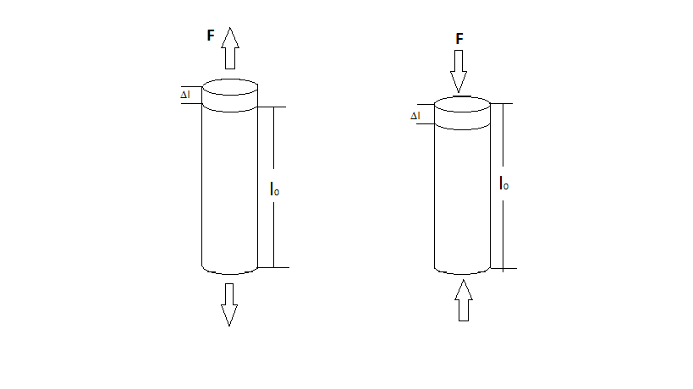

Under tension Under compression

Strain-on the application of applied external forces the internal stresses develops which results in the deformation (dimensional change) of the material in stress. The relative change in the material dimension is defined as strain normal strain is expressed as

(Where L is for length dimension**)** 

Some terminologies associated with stress-strain are:

**TRUE STRESS** -it is the force that acts per unit area. (area of application being

instantaneous)

$$σ_{TRUE} = \frac{f}{a_{inst}}$$

**TRUE STRAIN**-it is the ratio of the incremented length to the length at that instant. $$δϵ_{True} =\frac{δL}{L}$$

$ϵ_{TRUE} = \int_{L(o)}^{L(i)}{\frac{δL}{L}}= log⁡( \frac{L(i)}{L(0)} )$

Stress is related to strain of a ductile material and is depicted by

the qualitative graph given below:

Here, till yield point the graph is linear and the deformation occurs is elastic

after yield point the stress increases due to strain hardening and reaches to

ultimate stress point after which a uniform decrease in the cross section occurs

although there is a sudden increase in true stress due to which necking occurs

and finally the material fails as it reaches the fracture point.

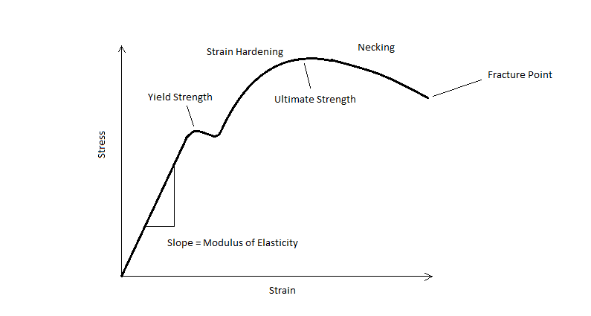

In contrast brittle material behave differently in concern with their stress

strain relation

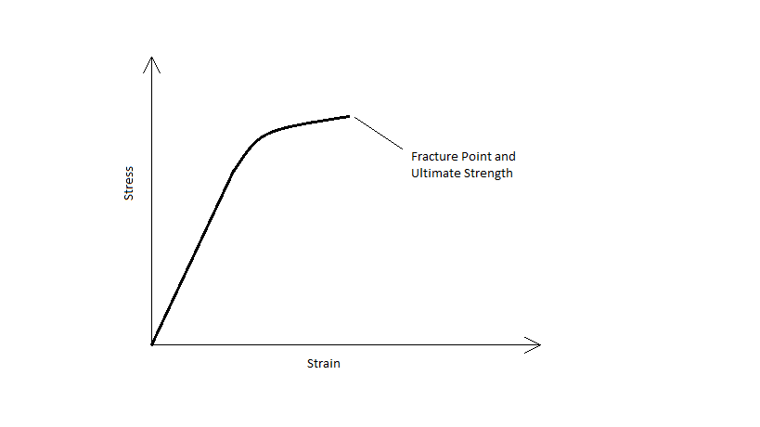

Here, the brittle materials behave linearly upto a certain stress

point after which even slight plastic deformation results in failure/fracture of the

material. Unlike ductile material they do not have a yield point and the point for

ultimate stress and fracture are the same.

**PROCEDURE:**

* Measurements of the sample are done. Then, it is held fixed between the fixtures in the Universal Testing Machine.
* UTM is controlled by the computer. The dimensions of the sample and strain rate are typed in the computer.
* UTM is first brought to zero load position. Then, the tensile load is applied.
* The sample is pulled/elongated till the sample fractures.
* Tests are conducted on two samples of Aluminium and one sample of Steel.
* For the aluminum cylinder sample, measurements are done, and then compressive load is applied.
* Data noted by the computer is used to plot graphs like Load-Extension curves and Stress-Strain curves.
* Yield Strength, Ultimate Strength, Young’s Modulus, Toughness and Modulus of Resilience are measures from the graph.

**SPECIMEN DATA:**

**INITIAL**

|  |  |  |  |
| --- | --- | --- | --- |
| **SAMPLE** | **LENGTH(mm)** | **WIDTH(mm)** | **THICKNESS(mm)** |
| Aluminium 1 | 84 | 15.2 | 3.41 |
| Aluminium 2 | 81 | 15 | 3.37 |
| Steel 1 | 57 | 11 | 2.87 |
| Steel 2 | 65 | 11.5 | 2.81 |

**FINAL**

|  |  |  |
| --- | --- | --- |
| **SAMPLE** | **WIDTH(mm)** | **THICKNESS(mm)** |
| Aluminium 1 | 14.52 | 3.14 |
| Aluminium 2 | 15.26 | 3.16 |
| Steel 1 | 10.46 | 2.81 |
| Steel 2 | 10.08 | 2.76 |

**Aluminium 1:**

|  |  |
| --- | --- |
| * **Peak Load** : 8,990.37 N (916.45 Kg-f) **At Extension** : 22.000 mm |  |
| * **Breaking Load** : 143.42 N (0.00 Kg-f) **At Extension** : 25.725 mm |  |
| * **Load at Proportional Limit** : 8,557.14 N (872.29 Kg-f) **At Extension** : 16.523 mm | |

**Aluminium 2:**

|  |  |  |
| --- | --- | --- |
| * **Peak Load** : 3,823.74 N (389.78 Kg-f**) At Extension** : 6.000 mm |  |  |
| * **Breaking Load** : 112.72 N (0.00 Kg-f) **At Extension** : 9.815 mm | |  |
| * **Load at Proportional Limit** : 3,196.43 N (325.83 Kg-f**) At Extension** : 4.455 mm | | |

**Steel 1:**

|  |  |
| --- | --- |
| * **Peak Load** : 10,415.28 N (1,061.70 Kg-f) **At Extension** : 16.000 mm |  |
| * **Breaking Load** : 107.62 N (0.00 Kg-f) **At Extension** : 19.507 mm |  |
| * **Load at Proportional Limit** : 10,535.71 N (1,073.98 Kg-f) **At Extension** : 16.114 mm | |

**Steel 2:**

|  |  |
| --- | --- |
| * **Peak Load** : 10,415.28 N (1,061.70 Kg-f) **At Extension** : 20.000 mm |  |
| * **Breaking Load** : 158.82 N (0.00 Kg-f**) At Extension** : 24.323 mm |  |
| * **Load at Proportional Limit** : 10,428.57 N (1,063.06 Kg-f) **At Extension** : 22.523 mm | |

**RESULTS AND GRAPHS:**

**RESULTS:**

**Specified Stresses for tangent and secant modulus:**

|  |  |
| --- | --- |
| **SAMPLE** | **STRESS (GPa)** |
| Aluminium 1 | **0.1650937645** |
| Aluminium 2 | **0.0632330366** |
| Steel 1 | **0.3337253722** |
| Steel 2 | **0.3227160761** |

|  |  |  |  |  |  |  |  |
| --- | --- | --- | --- | --- | --- | --- | --- |
| **S.No.** | **SAMPLE** | **Young’s Modulus**  **(GPa)** | **Secant Modulus of Elasticity**  **(GPa)** | **Tangent Modulus of Elasticity**  **(GPa)** | **Ultimate Tensile Strength**  **(GPa)** | **Fracture Strength**  **(GPa)** | **%Reduction in Area** |
| **1.** | **A 1** | **3.583517** | **1.039915** | **0.20329486** | **0.1734521** | **2.7670165** | **12.037** |
| **2.** | **A 2** | **2.36733** | **3.180904** | **1.91096383** | **0.075642729** | **2.2298714** | **4.6061** |
| **3.** | **S 1** | **2.457642** | **2.116894** | **0.36947040** | **0.3299106747** | **3.4089325** | **6.897** |
| **4.** | **S 2** | **2.077784** | **1.19748** | **0.0042867** | **0.322304812** | **4.9147454** | **13.907** |

|  |  |  |  |
| --- | --- | --- | --- |
| **S.No.** | **SAMPLE** | **YIELD STRESS (GPa)** | **%ELONGATION** |
| **1.** | **A1** | **0.110856478** | **29.463** |
| **2.** | **A2** | **0.1159233761** | **9.935** |
| **3.** | **S1** | **UYS- 0.286821**  **LYS- 0.254577** | **32.4035** |
| **4.** | **S2** | **UYS- 0.254577**  **LYS- 0.24115095** | **35.8246** |

**Calculations:**

Modulus of resilience = Yield stress2/(2*(Young's modulus))

Young’s modulus= slope of Load-Deflection graph* (Length/Area)

Ultimate Tensile Strength= Peak Load/Area

Toughness= Area under Load-Deflection Curve / Volume

Yield Strength =Yield Point Load/Area

%Elongation = (final length-initial length)/ (initial length)*100

%area reduction = | (final area – initial area)|/ (initial area)

Fracture strength = Fracture load / Area

**Discussion:**

Through this experiment, we understood various properties like yield point, Ultimate tensile strength, elastic limit, fracture, necking etc.

Because of the various impurities and defects in the material, it causes much larger deformations, leading to higher strains than expected. As compared to the ideal case, in which the specimen breaks at the center. It is because of the uniformly distributed load. However, here, it didn’t break at the center. It is because of the unevenness in the specimen because of the impurities. Hence, we could not predict the fracture in advance.

**Conclusion:**

In this experiment we measured yield strength, ultimate Tensile strength, young’s modulus, toughness, stiffness etc. of materials like steel and aluminum

We note that aluminum have very less strength as compared to steel. The deformation region ends with sudden fracture.

**Precautions:**

* A paper should be placed above and below the specimen so that machine does not get damaged.
* Care should be taken while changing the fixtures in the machines.
* Dimensions of the specimen should be measured and entered in the machine carefully.

**Bibliography:**

* Materials Science and Engineering, An Introduction (Eighth Edition) by William D. Callister, Jr. and David G. Rethwisch.
* Class Notes Structure and Properties of Materials, ME 222A, Prof. Kamal K. Kar
* Wikipedia